Steven Kim  
Mr. Mason  
Adv Cisco CCNP P12  
2/10/14

Lab 7: Multicast Routing

**Purpose**

The purposes of this lab were to research different kinds of multicasting and configure a router so that it can control multicasts on a network.

**Background Information on lab concepts**

Multicast: The transportation of information to a group of hosts through a single transmission from the source. Multicast is often used in IP protocols and applications; routers usually act as servers that distribute information. At the Data Link Layer, multicast describes one-to-many distribution. The source has no knowledge of the receiver. A one-to-many distribution is a distribution in which one source (or server) sends information to multiple receivers in the same network as the server.

Internet Group Management Protocol (IGMP): A communication protocol implemented to establish multicast connections. IGMP is often implemented in one-to-many networks and plays a crucial role in IP multicast. They are transported in pure IP packets and do not go through the Transport Layer.

CGMP: CGMP is simply a Cisco version of IGMP.

Protocol Independent Multicast (PIM): A type of IP multicast that distributes date over a LAN. PIM cannot obtain the topology directly; it uses routing information that come from various routing protocols. However this type of multicast is “Protocol Independent” because it does not rely on unicast routing protocols.

* PIM Sparse Mode (PIM-SM): A protocol designed for efficiently spreading information by creating shortest-path trees per source. It is often used for scaling wide-areas; it presumes a very low number of receivers. Thus, by directly creating a tree for sending multicast packets to receivers in the same network as the source, meaning that the source in Sparse mode explicitly knows where the Sparse mode can deliver packets more accurately than Dense mode.
* PIM Dense Mode (PIM-DM): A type of multicast that uses dense can establish a data structure (tree) to send information to multicast receivers. Unlike Sparse mode that creates a tree, Dense mode is used by multicast for sending multicast packets to receivers. Although Dense mode is easier to implement than Sparse mode, Sparse mode has better scaling tendencies than Dense mode.

User Datagram Protocol (UDP): A transportation protocol that sends data over the Data Link Layer. UDP, unlike Transmission Control Protocol (TCP), does not have a three-way-handshake mechanism to verify data; thus, it is faster than TCP, but less accurate. UDP was used by multicast to deliver information to hosts.

General Hardware-Oriented System Transfer (GHOST): A program used for cloning and backing up other programs. It is transferred in an ISO image file that needs to be put on a CD. To verify multicast in this lab, I used GHOST and attempted to transfer the ISO image file that was in the server to the hosts that received multicast.

Dynamic Host Control Protocol (DHCP): A networking protocol that automatically (dynamically) assigns IP addresses to devices in the same network as the server. DHCP removes the inconvenience of having to statically configure different IP addresses, especially when it comes to assigning IP addresses to IP phones.

**Lab Summary**

The three main steps for this lab were configuring the router so that it acts as a multicast source, ghosting the two PCs, and verifying that the router is controlling multicasts throughout the network by capturing its packets with Wireshark.

**Steps for configuring the Router**

1. Set up the DHCP server using the commands. Verify that the DHCP server is working by connecting a host to it.
2. Issue the command *Router (config)# ip multicast-routing* to enable multicasting.
3. Enter the router’s interface and issue the commands *Router (config-if)# ip pim sparse-dense mode* and *Router (config-if)# ip cgmp.* These commands will place the router in Sparse-Dense mode, which is an interchangeable mode, and implement the Cisco proprietary IGMP, CGMP.

**Steps for Ghosting two PCs**

Before Ghosting the PCs, verify that the server is connected to the central switch with a patch cable.

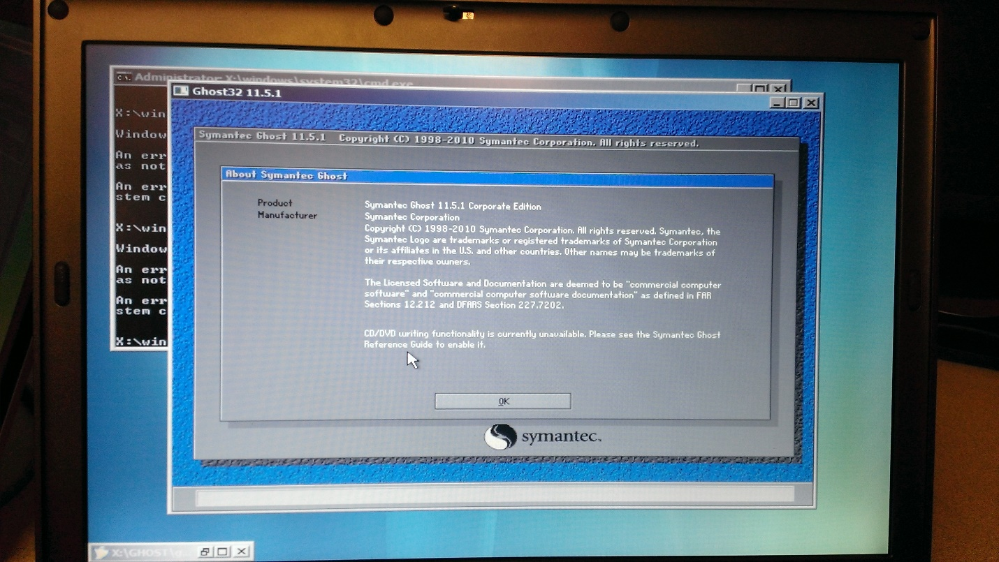

Boot the Ghost server. A loading image like the picture above should show up.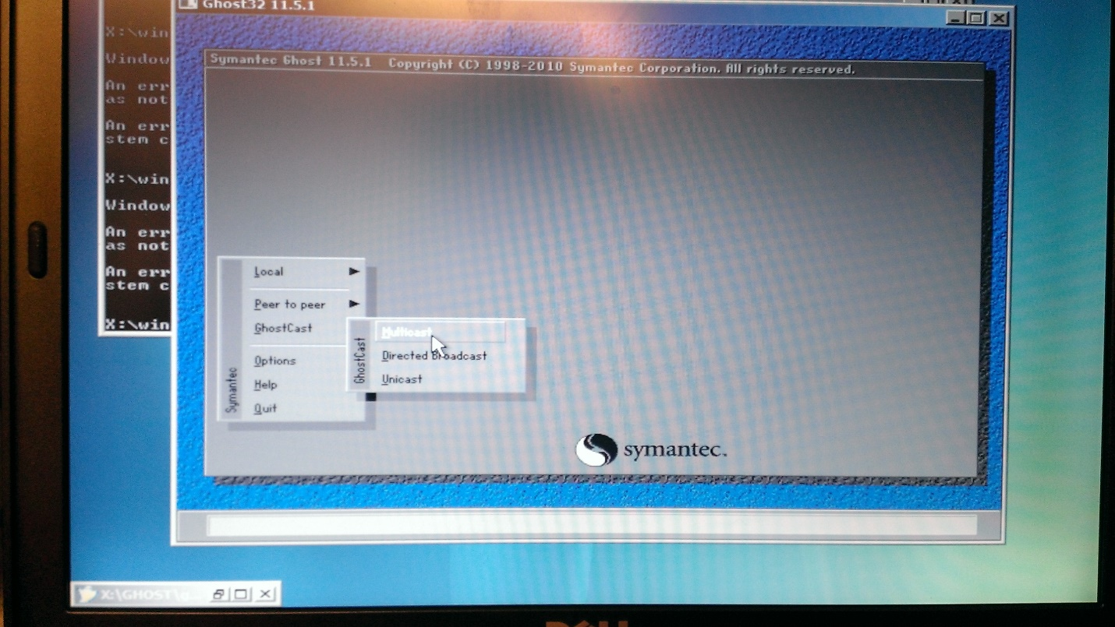

On the left side of the menu, move to cursor to Ghost Cast, then select Multicast.

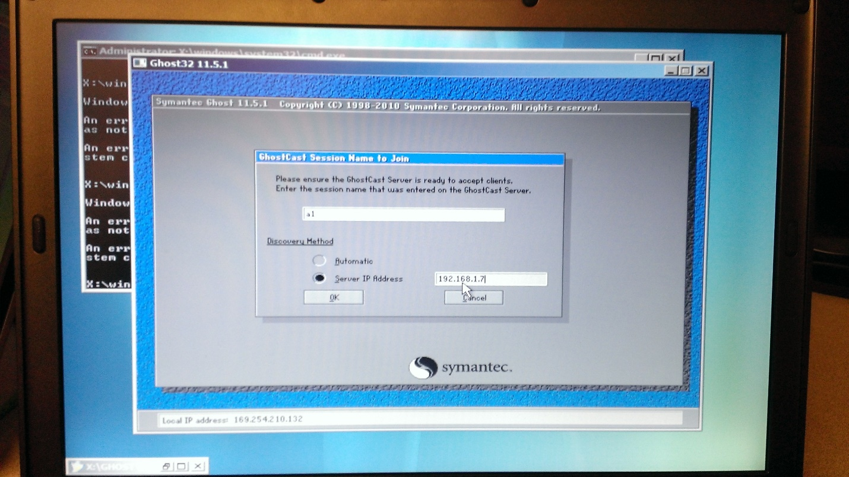Enter the IP address of the Ghost Server. Click Ok to proceed. 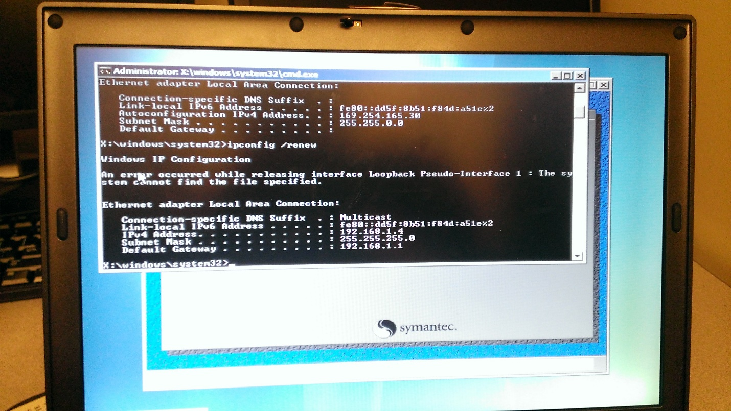

Using the DHCP server (and making sure that the DHCP server is properly working), assign IP addresses to the two hosts that are to be configured using multicast packets.

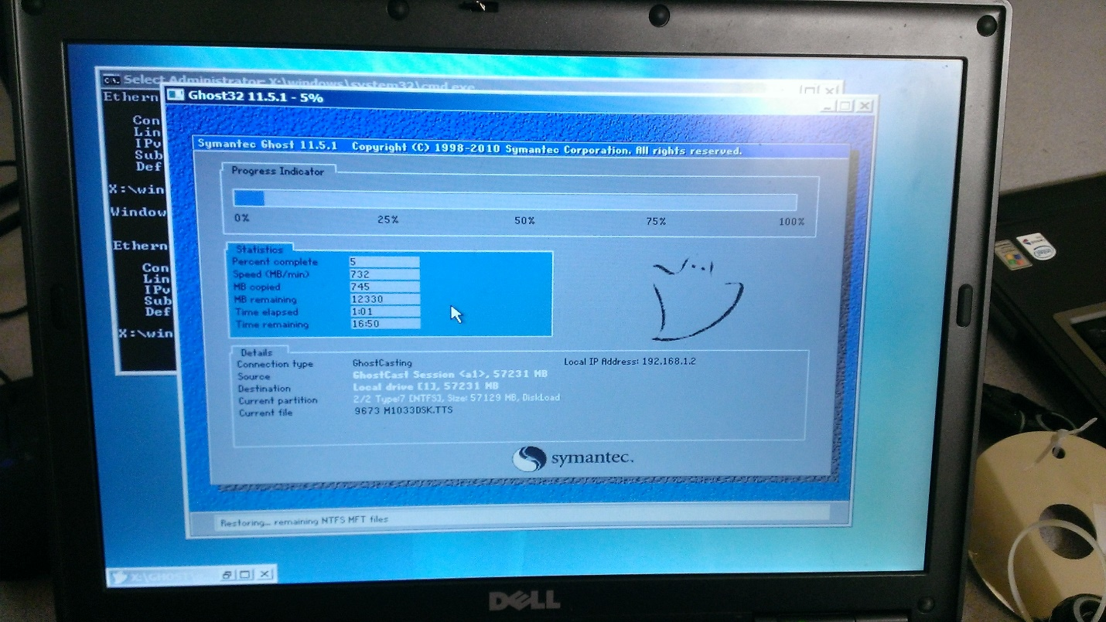

A loading image like the picture above will appear indicating that Ghosting is in progress.

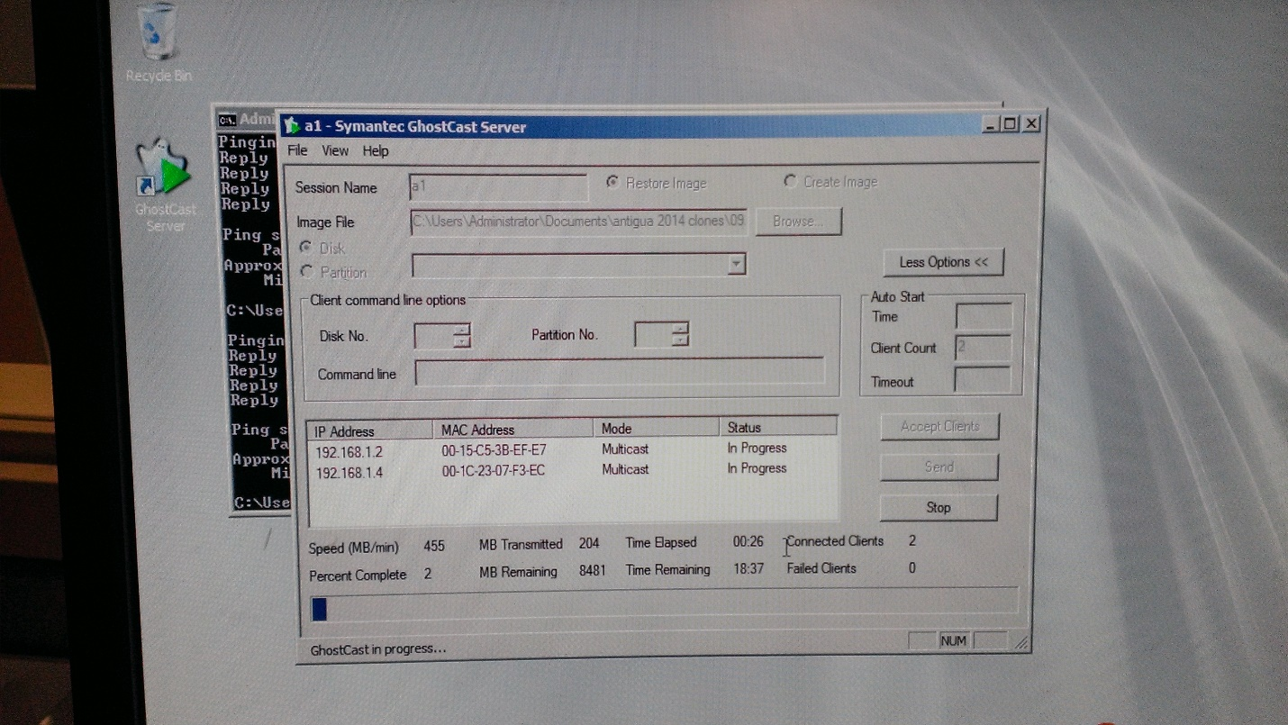

Go back to the Ghost Server. Wait until the two PCs have been hosted.

**Steps for verifying that the router is controlling multicasts**

In case the Ghost image files were delivered without multicast packets, I verified that the router could fully control multicast packets by running Wireshark to capture UDP, PIM v2 (hello packets) NBNS (Ghost Cast), IGMP, and CGMP files.

IGMP and CGMP Captures

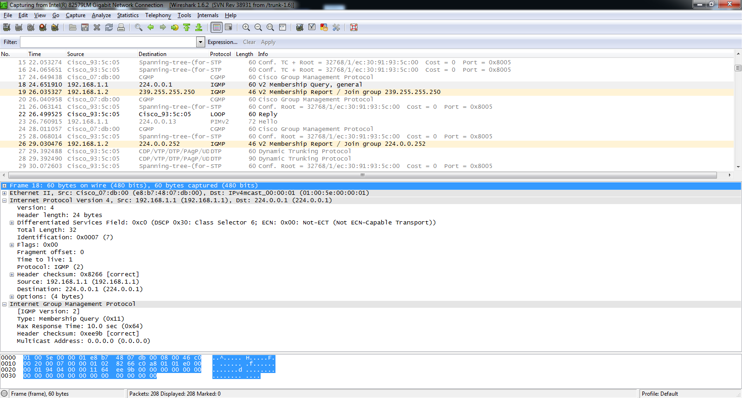

The capture above shows IGMP packets that request to “join group 224.0.0.252.” It also reveals the IGMP version and its designated multicast address.

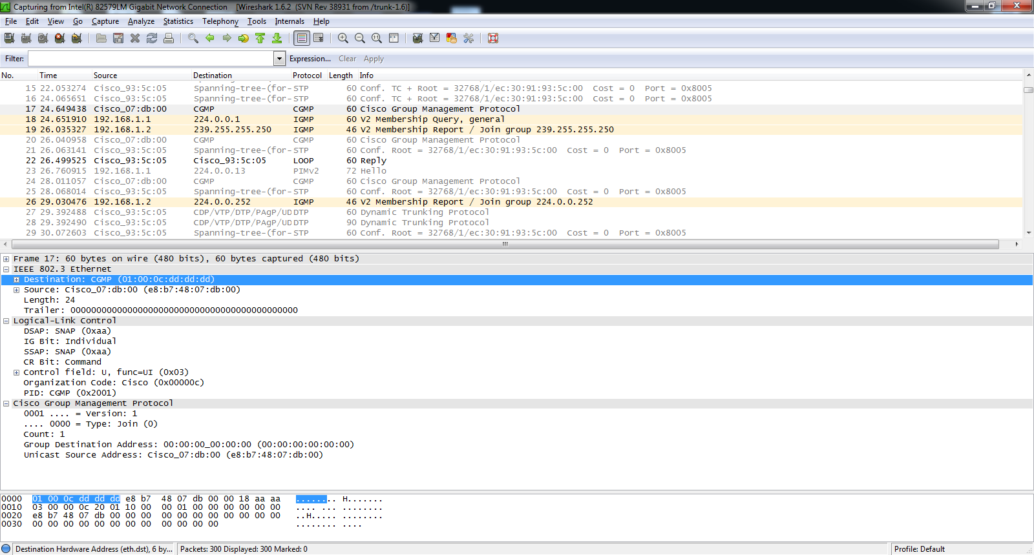

The capture above shows that the Cisco Group Management Protocol (CGMP) is a part of multicasting. It also verifies that the router is successfully using this protocol to control multicast packets.

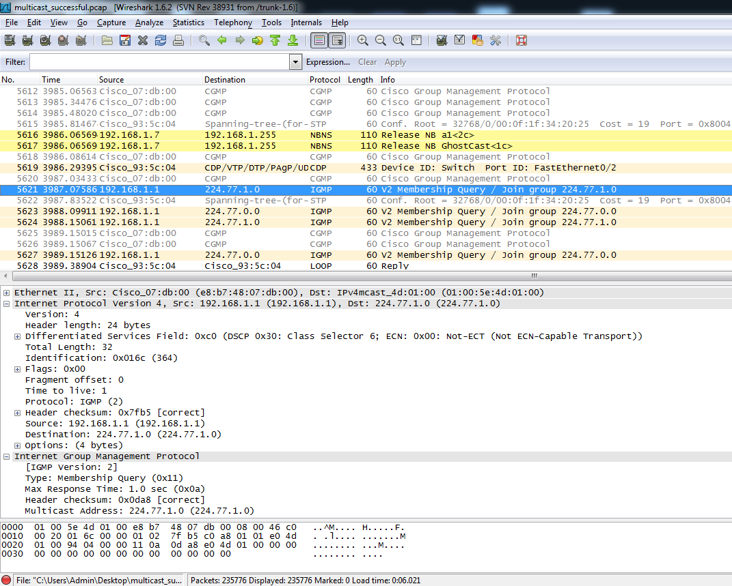

The capture above shows a multicast address (224.77.1.0) that is being used as a part of IGMP. The packet information indicates the packets’ destinations and group memberships.

NBNS and Ghost Cast Capture

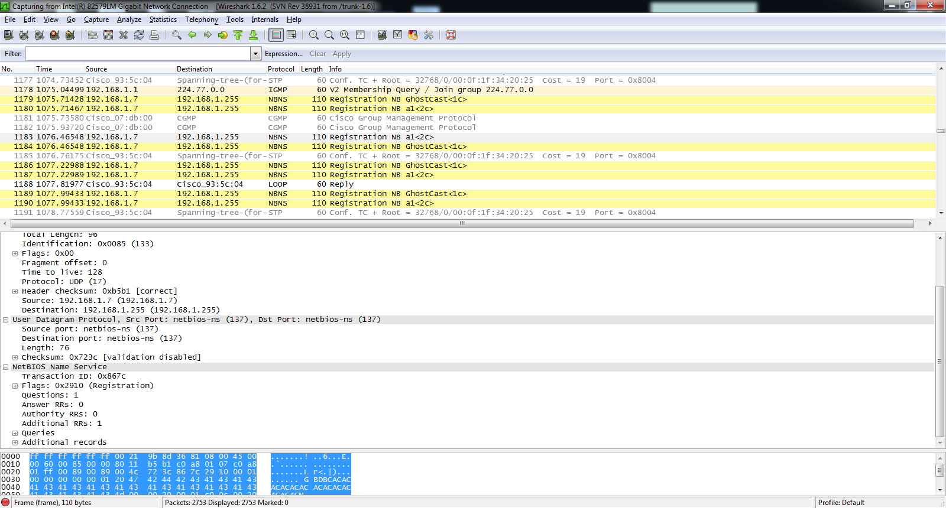

The capture above shows that Ghost Cast is in progress. In the packets’ descriptions, User Datagram Protocol (UDP) is also used.

UDP Capture

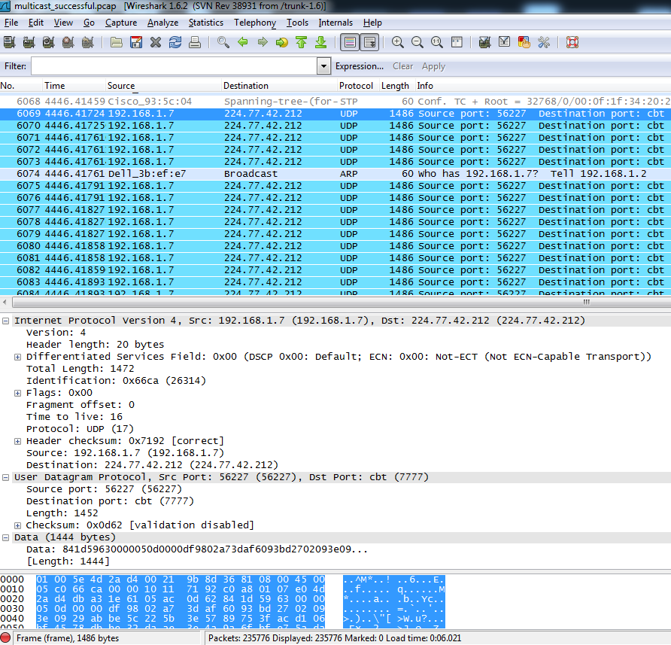

Above shows UDP packets that are transferred as a result of the router’s controlling multicast packets. Notice that the destination addresses of these packets start with 224, indicating that they are a part of multicasting.

PIMv2 Capture

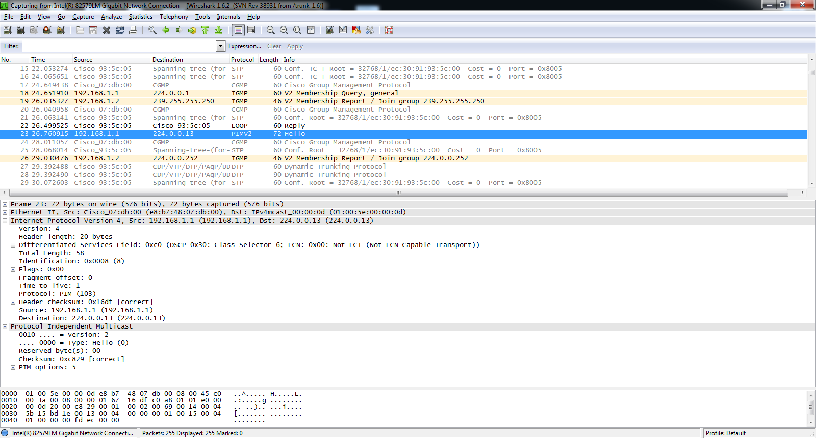

This capture shows a hello packet indicating that PIM v2 (Sparse-Dense mode) has been successfully implemented. A multicast address that starts with 224 (full address:224.0.0.13) also indicates that the router is controlling multicast packets.

**Lab Commands**

|  |  |
| --- | --- |
| Router (config)# ip multicast-routing | Enables multicast routing on Layer 3 (IP) |
| Router (config-if)# ip pim sparse-dense mode | Enables PIM to be configured in both sparse and dense mode, depending on the status of the network |
| Router (config-if)# ip cgmp | Enables the cisco proprietary version of IGMP, CGMP. |
| Router (config) #ip dhcp pool [*name of the DHCP server]* | Configures the pool name of the DHCP server. |
| Router (dhcp-config)# network [*network address of the server]* | Configures the network address of the DHCP server. |
| Router (dhcp-config)# dns-server [*ip address of the DNS server]* | Configures the IP address of the DNS server. |
| Router (dhcp-config)# default-router [*ip address of the default router]* | Sets the IP address of the default router (gateway) |

**Network Diagram with IP’s  
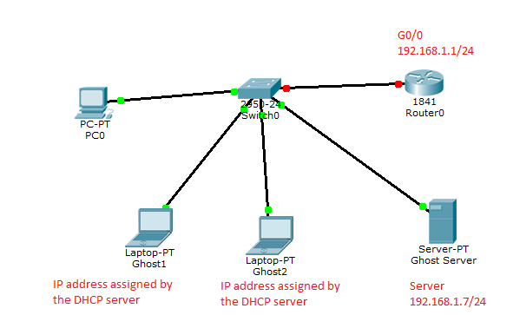**

**Configurations**  
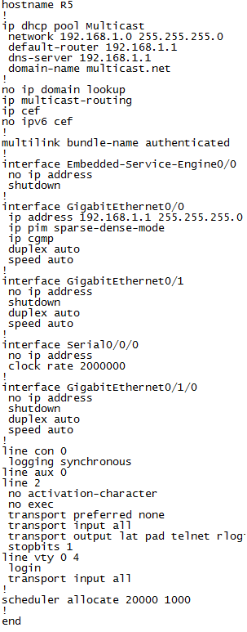

**Problem**

The main problem I had in this lab was troubleshooting the GHOST server. Often times, the Server responsible for transferring the GHOST file would either “not be able to enter the USB mode.” Since this error meant that I had entered wrong commands into the router or that connections were not established well, I had to check for all possibilities. Although I eventually found out that it was a Layer 1 issue, meaning that the USB responsible for transferring GHOST did not function properly, and that my DHCP Server had not been functioning properly, I spent the majority of my time troubleshooting the router commands that possibly made my server malfunction. Still, the commands for configuring the router were relatively easy compared to those of previous labs that I have done.

**Conclusion**

Overall, I managed to multicast the GHOST server’s information to two hosts and verified that the Multicast was working using Wireshark. Although had some minor issues like the DHCP server’s malfunctioning, or having a malfunctioned USB, I managed to verify that multicast was working properly, a skill that will be valuable as a CCNP when having to transfer information to multiple hosts over the same network as the server.